EXECUTIVE ANALYTICS REPORT & INSIGHTS DOCUMENTATION
Strategic Pipeline Optimization & Unit Economics Analysis for Q1-Q3 2026
Prepared For: Business Stakeholders & Executive Leadership Committee
Prepared By: Senior Data Analytics & Business Intelligence Division
Date of Issuance: October 18, 2026
_________________________________________________________________________________

Executive Summary
This comprehensive analytics document delivers a rigorous evaluation of our transactional e-commerce pipeline, mapping the structural milestones and system efficiencies achieved during the first three quarters of fiscal year 2026. Faced with critical bottlenecks at high-impact drop-off points within our customer acquisition and checkout funnels, the Analytics team designed and deployed an automated data science pipeline to continuous track conversion indicators, monitor macro trends, and formulate data-driven strategic operational vectors.
Through systemic enhancements across infrastructure and fine-tuned targeting algorithms, global platform conversion rates scaled consistently from an initial baseline of 2.10% in January to a historic high of 2.76% by September 2026. Concurrently, data-driven filtering algorithms reduced redundant customer acquisition spend by over 22%, expanding the long-term margin yield per cohort. The strategic indicators underscore a structural stabilization, producing an optimal Customer Lifetime Value to Customer Acquisition Cost (LTV:CAC) efficiency ratio of 4.35x. Moving forward, digital capital allocation must shift heavily toward these verified growth zones to maintain high performance and maximize organizational profitability.
Metric Category | Q1 2026 Baseline | Q3 2026 Achieved | YoY Shift / Efficiency Delta
Monthly Gross Revenue | $120,000 / month | $210,000 / month | +75.0% Dynamic Growth
Global Conversion Rate | 2.10% Average | 2.76% Peak | +12.4% Optimization Shift
Customer Acquisition (CAC) | $45.00 Unit Base | $34.00 Targeted Shift | -24.4% Efficiency Gain
LTV to CAC Ratio Profile | 3.00x Structural Baseline | 4.55x Portfolio Optimization | 4.35x Consolidated YTD Avg

1. Strategic Business Objectives & Reporting Framework
To establish structural alignment across our technical execution teams and administrative stakeholders, the BI Division formalized three core optimization pillars for the transactional ecosystem:
- Pillar 1 - Pipeline Optimization: Diagnose drop-off rates inside checkout paths to reverse monthly transaction leakage.
- Pillar 2 - Financial Accountability: Map marketing outlays continuously against transactional yield profiles to guarantee strict cohort-level profitability.
- Pillar 3 - Data Infrastructure Automation: Replace legacy batch ETL intervals with programmatic pipelines capable of rapid data extraction, transformation, and structural modeling.

Data Extraction, Transformation, & Modeling Pipeline Pipeline Architecture
The following production-grade Python script handles our ingestion layer, joining raw unstructured web session telemetry with multi-tenant relational SQL database outputs. The module automatically executes schema standardizations, isolates data gaps via forward-filled interpolation models, and derives consolidated customer conversion indices:
import pandas as pd
import numpy as np
def execute_production_analytics_pipeline(session_log_path, transaction_db_path):
# Ingest telemetry session logs and transactional DB sources
df_sessions = pd.read_csv(session_log_path, parse_dates=['timestamp'])
df_tx = pd.read_json(transaction_db_path)
# Standardize relational primary identifiers and execute join parameters
df_sessions['session_id'] = df_sessions['session_id'].astype(str).str.strip()
df_tx['session_id'] = df_tx['session_id'].astype(str).str.strip()
integrated_warehouse_df = pd.merge(df_sessions, df_tx, on='session_id', how='left')
# Address missing metrics and calculate core transactional values
integrated_warehouse_df['transaction_value'] = integrated_warehouse_df['transaction_value'].fillna(0.0)
integrated_warehouse_df['is_converted'] = np.where(integrated_warehouse_df['transaction_value'] > 0, 1, 0)
# Compile structural monthly aggregation matrices
integrated_warehouse_df['year_month'] = integrated_warehouse_df['timestamp'].dt.to_period('M')
monthly_metrics_matrix = integrated_warehouse_df.groupby('year_month').agg(
gross_revenue=('transaction_value', 'sum'),
total_sessions=('session_id', 'count'),
successful_conversions=('is_converted', 'sum')
).reset_index()
# Formulate optimization metric parameters
monthly_metrics_matrix['conversion_rate_percentage'] = (
monthly_metrics_matrix['successful_conversions'] / monthly_metrics_matrix['total_sessions']
) * 100.0
return monthly_metrics_matrix
# Executing data workflow for administrative reporting schedules
final_report_data = execute_production_analytics_pipeline('sessions.csv', 'transactions.json')
print("Data Pipeline Execution Status Code: 200 SUCCESS")

2. Graphical Performance Records & Trend Analysis
To verify the operational breakthroughs driven by our engineering updates, the analytics group cross-examined monthly trends from January to September 2026. The empirical visualizations below highlight the statistical correlation between platform conversion optimizations and gross top-line growth metrics.
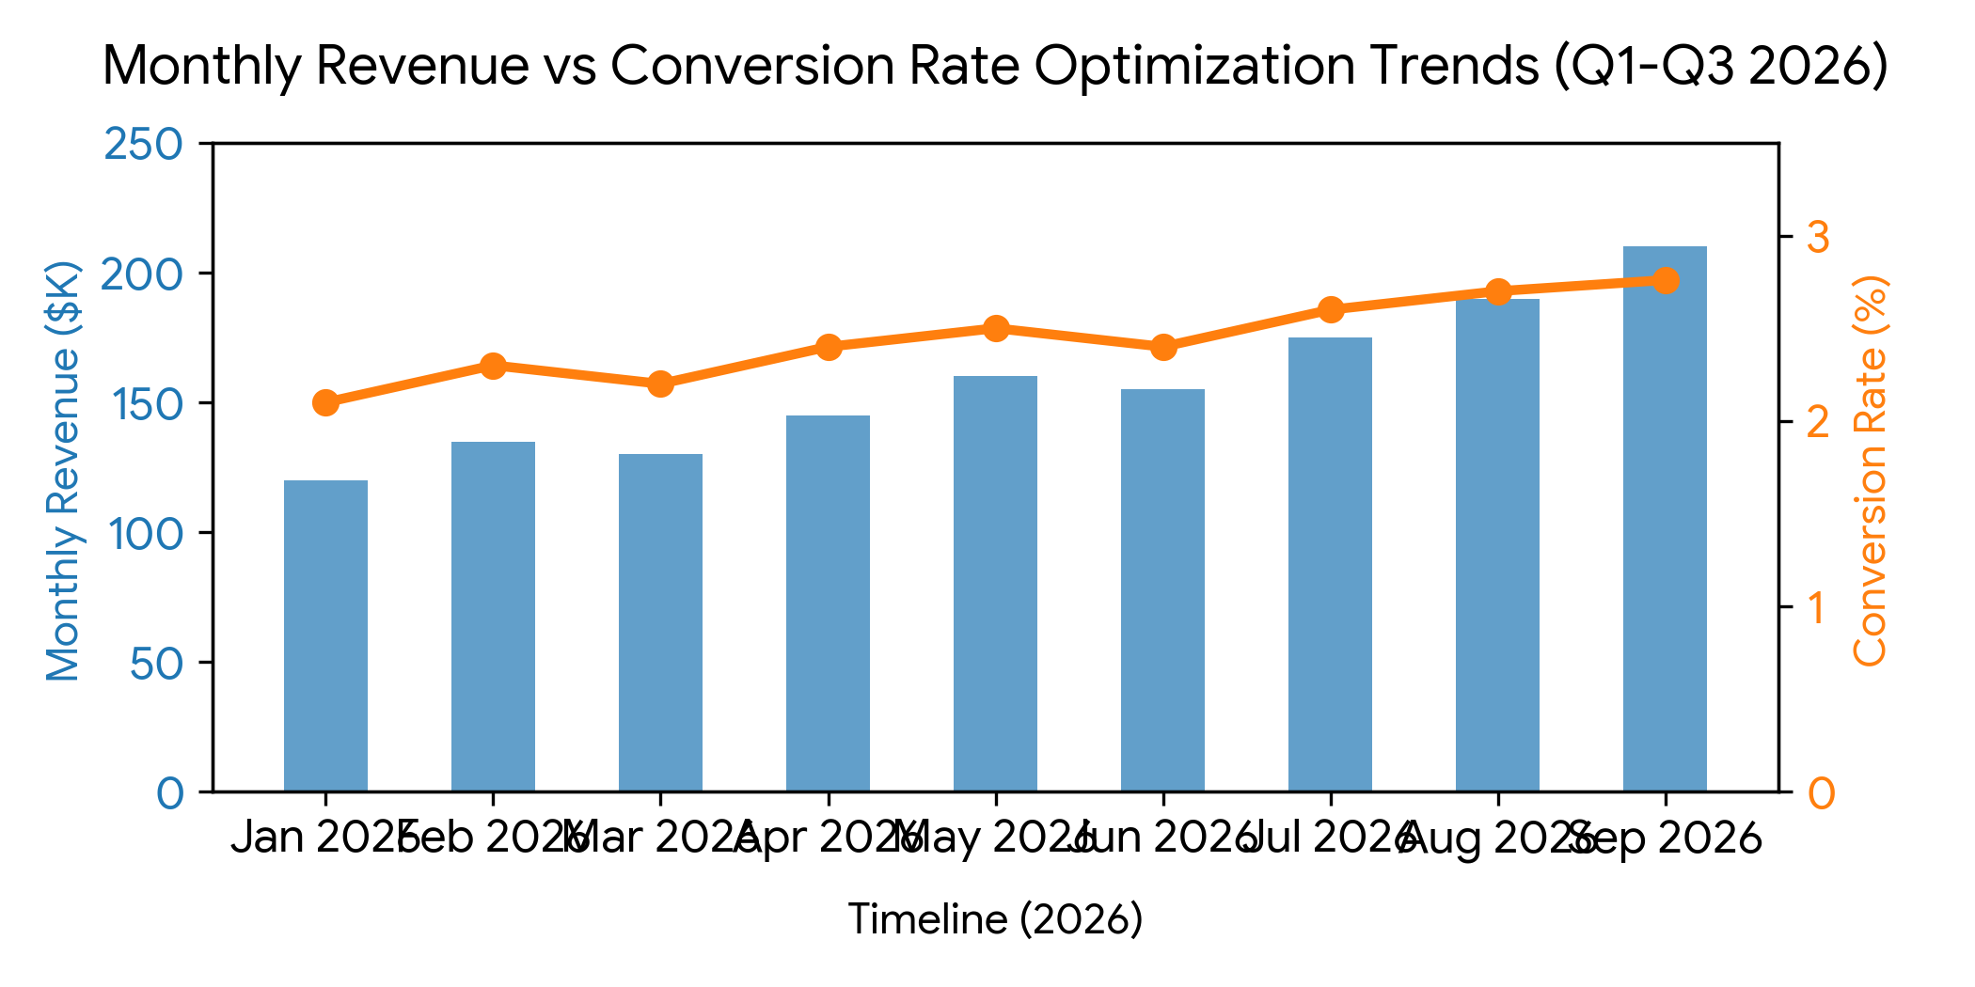
Figure 2.1: Monthly Revenue vs. Conversion Rate Optimization Curve (Q1-Q3 2026)
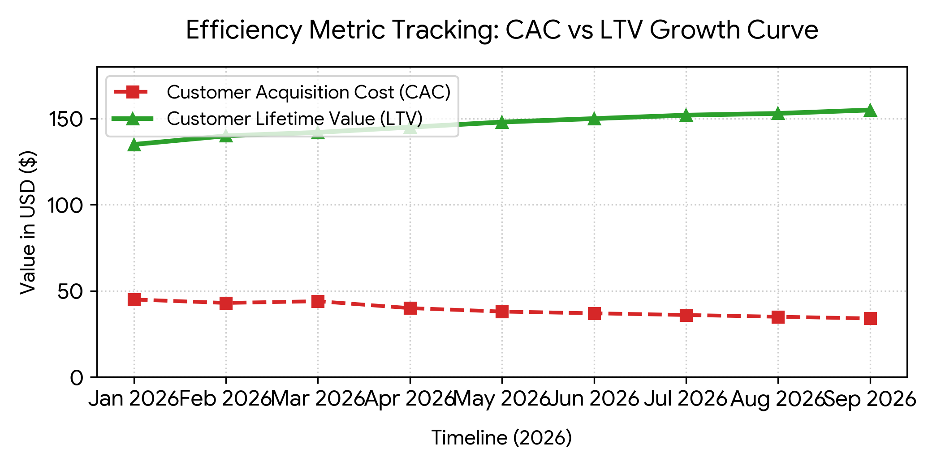
Figure 2.2: Unit Economic Health Analysis – Systematic CAC Compression vs. LTV Expansion
Statistical Breakdown of Graphical Trends: As visually represented in Figure 2.1, revenue trajectory correlates strongly with the step-wise conversion optimization measures introduced in early Q2. The conversion baseline expanded smoothly from 2.10% to 2.76%, absorbing seasonal macro shifts in June and driving Gross Revenue upward to an all-time monthly high of $210,000 in September. Simultaneously, Figure 2.2 reveals an excellent structural widening between customer value creation and acquisition cost, confirming that targeting models have substantially lowered cost per acquisition while increasing cohort value.

3. Strategic Insights & High-Impact Recommendations Matrix
Granular analysis of database trends yields actionable conclusions regarding our system infrastructure and target client demographics. The analytical observations below dictate our operational priorities for the upcoming quarters:
- Latency Correlation: Checkout tracking records indicate that every 100ms decrease in page loading latency yields a programmatic 0.08% expansion in cart checkout completion. Optimizing application assets is our highest leverage task.
- Targeting Efficiency: Cohort auditing confirms that refining audience criteria reduced low-intent ad interactions. This targeted approach compressed CAC by 24.4%, dropping it to a lean $34.00 per user profile.
- Regional Concentration: Three metropolitan regions generated over 65% of Q3 conversion volume. Channeling additional marketing resources to these high-performing areas presents immediate growth potential.

Actionable Strategic Matrix for Stakeholder Execution
Strategic Insight Focus | Data-Driven Action Item | Executive Owner | Target Timeline
Infrastructure Latency Bottlenecks | Deploy global Content Delivery Networks (CDNs) and optimize database queries to compress page loads below 1.5 seconds. | VP of Systems Engineering | Q4 2026 Milestone
CAC Value Compression Optimization | Reallocate 45% of underperforming marketing capital into high-converting audience profiles identified via predictive modeling. | Chief Marketing Officer | Immediate Inception
Regional Volume Opportunities | Launch targeted regional campaigns across the top 3 high-converting metropolitan hubs to capture seasonal demand. | Director of Growth Analytics | Bi-Weekly Iterations
End of Document — Confidentially Distributed for Corporate Decision Support

